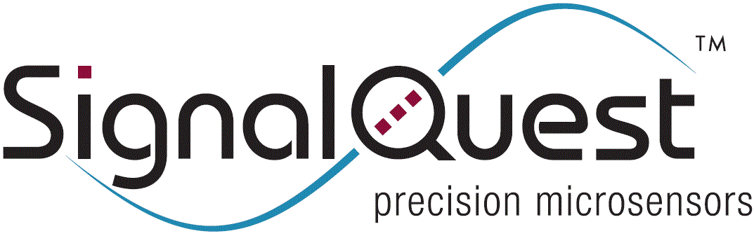 | SignalQuest Order Form | SignalQuest, LLC  10 Water St.  Lebanon, NH 03766  (tel) 603.448.6266  www.signalquest.com  sales@signalquest.com
 | QF-109

 |  | For SignalQuest use
Purchase Order No / Customer Reference No |  | Order No | Date Processed
Tel | Fax | Email

Credit Card Information
Please call after emailing your order to provide credit card or other payment information.

Bill To |  |  | Ship To | Same as billing address
Billing Company |  |  | Ship to Attn
Billing Street Address 1 |  |  | Shipping Street Address 1
Billing Street Address 2 |  |  | Shipping Street Address 2
City | State / Province |  | City | State / Province
Zip / Postal Code | Country |  | Zip / Postal Code | Country

Shipping Information
Priority Overnight Standard Overnight 2nd Day Ground International Other
Shipping Account No |  | If other, please specify
If a shipping account number is not provided, SignalQuest will notify customer of the additional shipping charges based on the shipping method selected.

Order information
Item | Qty | Unit Price | Extended Price
Subtotal
Shipping
Order Total |  |  | USD $

